PROJECT TITEL: HOTEL MANAGEMENT SYSTEM

OUTPUT:

FIG.1:

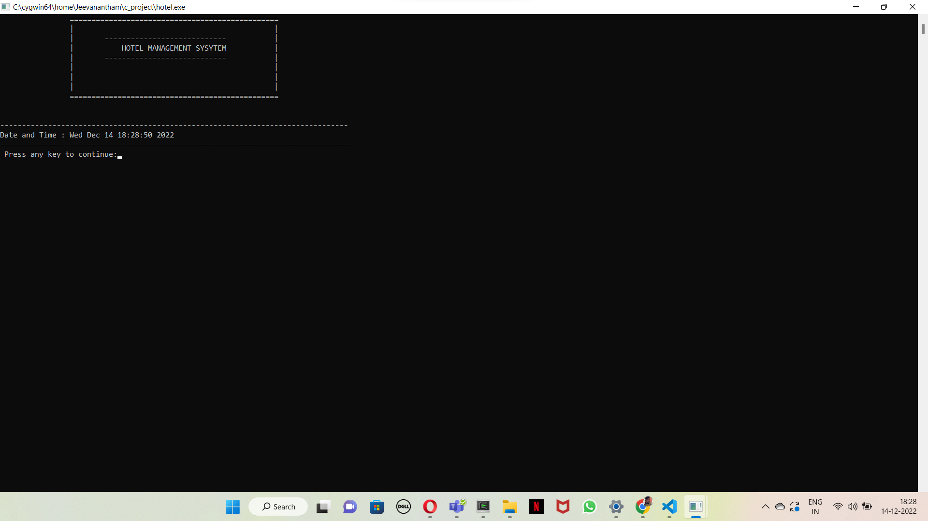

FIG.2:

ADMIN LOGIN PAGE:

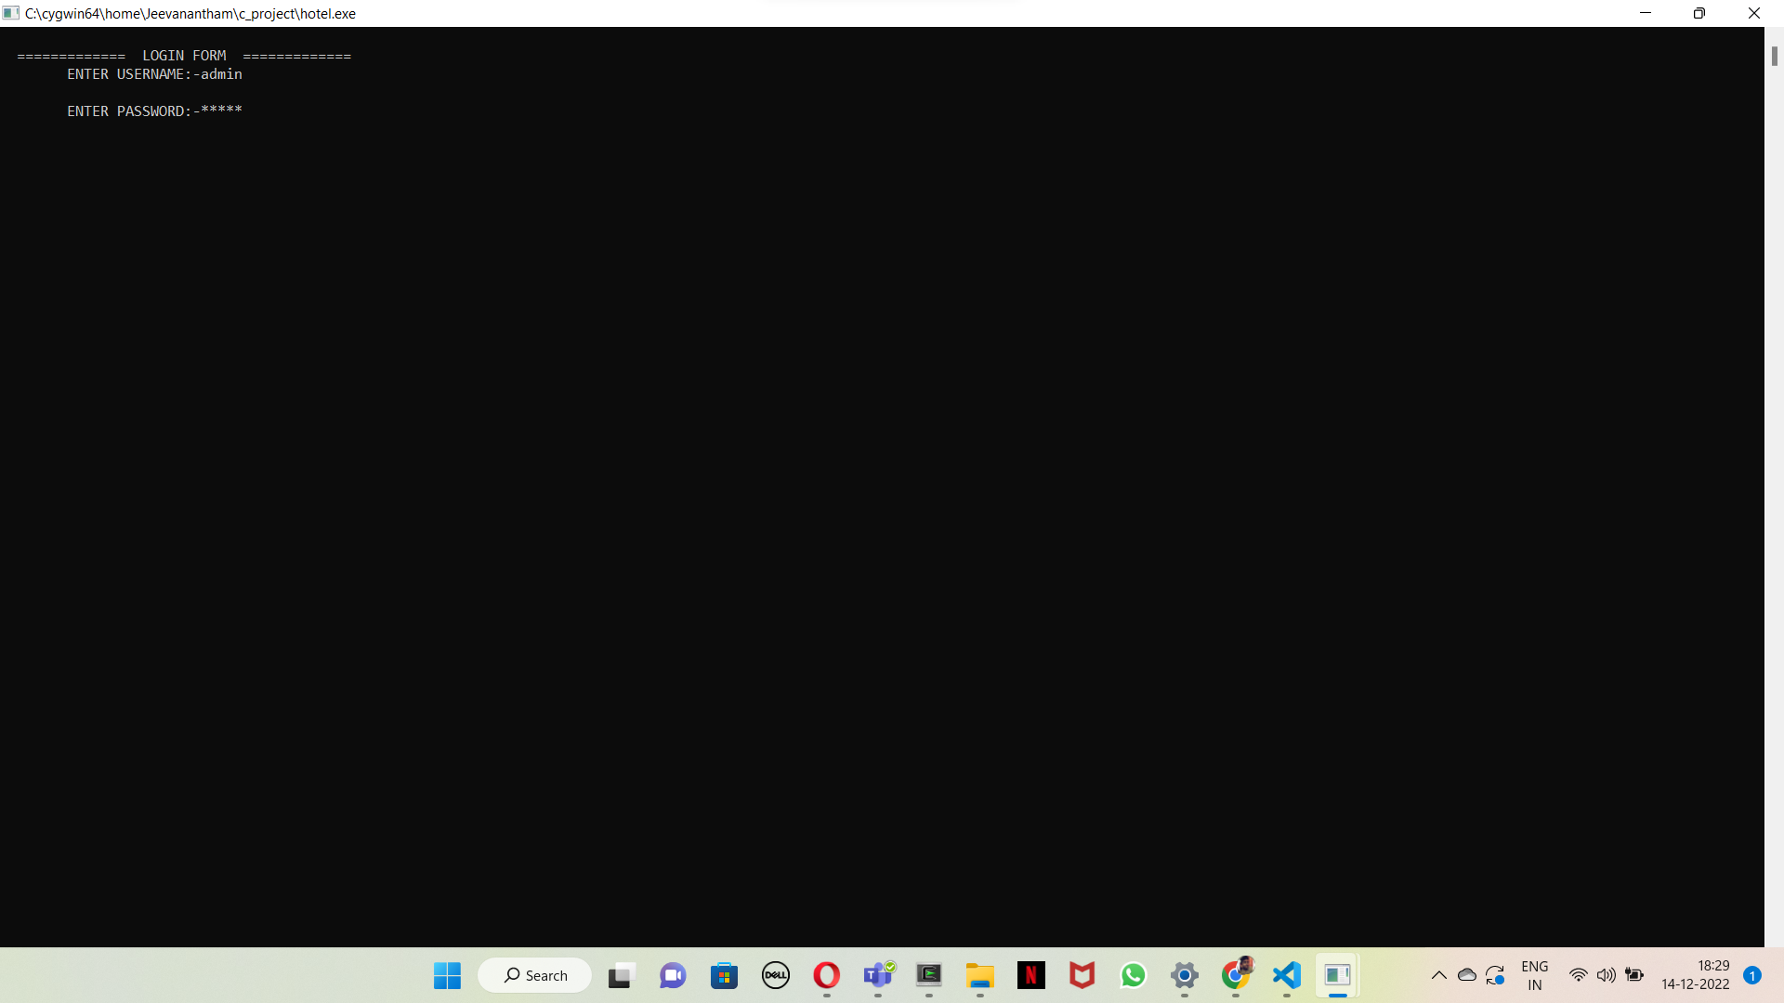

FIG.3:

MAIN MENU:

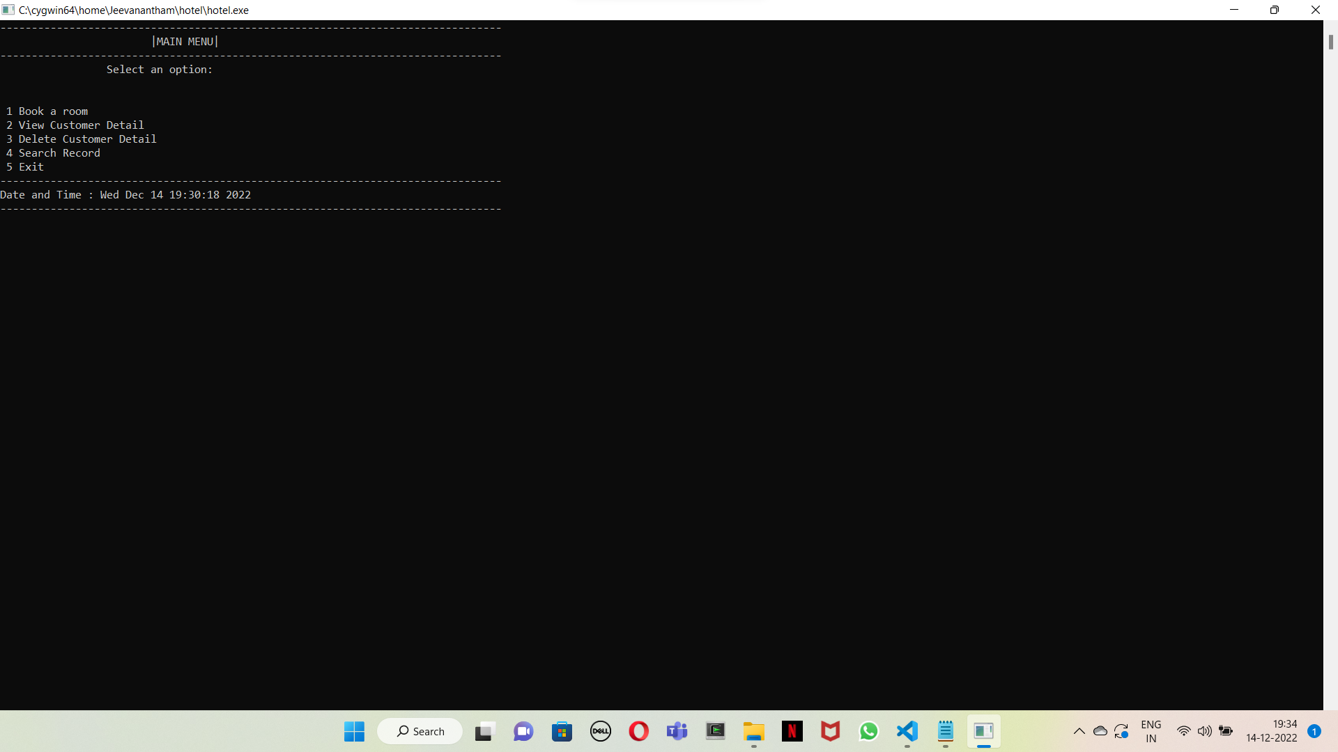

**ROOM BOOKING:**

**FIG.4:**

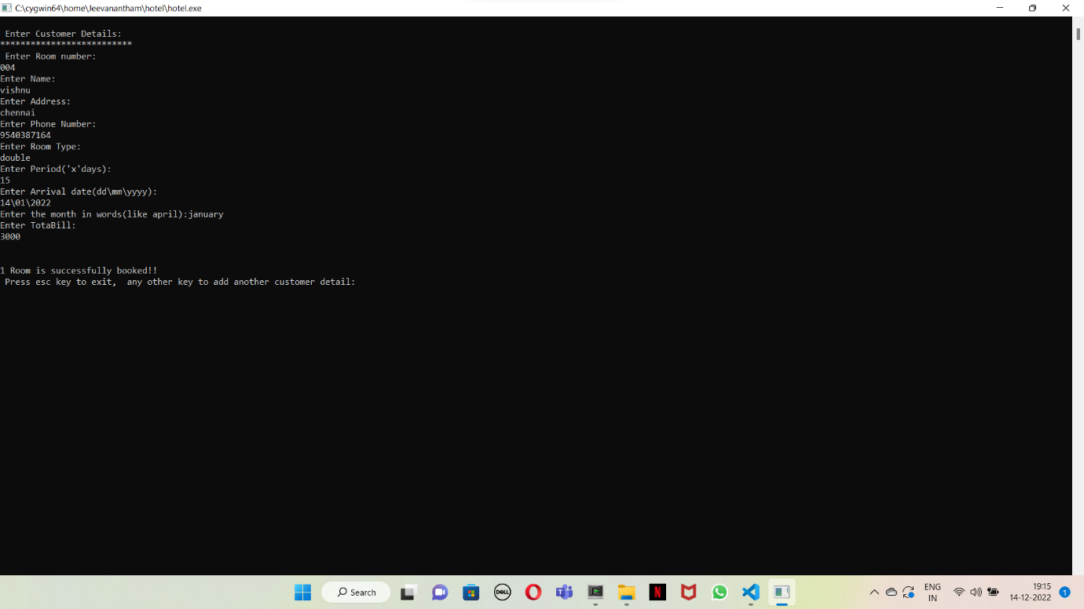

FIG.5:

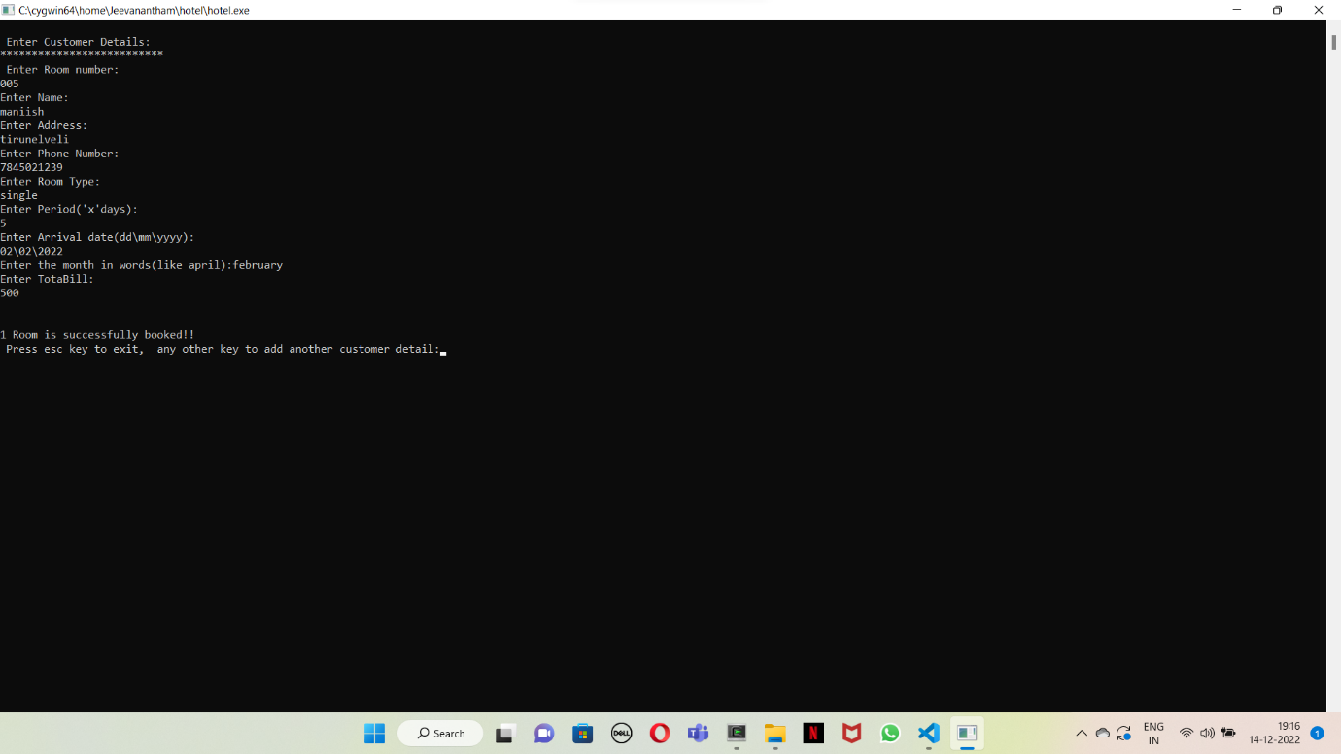

FIG. 6:

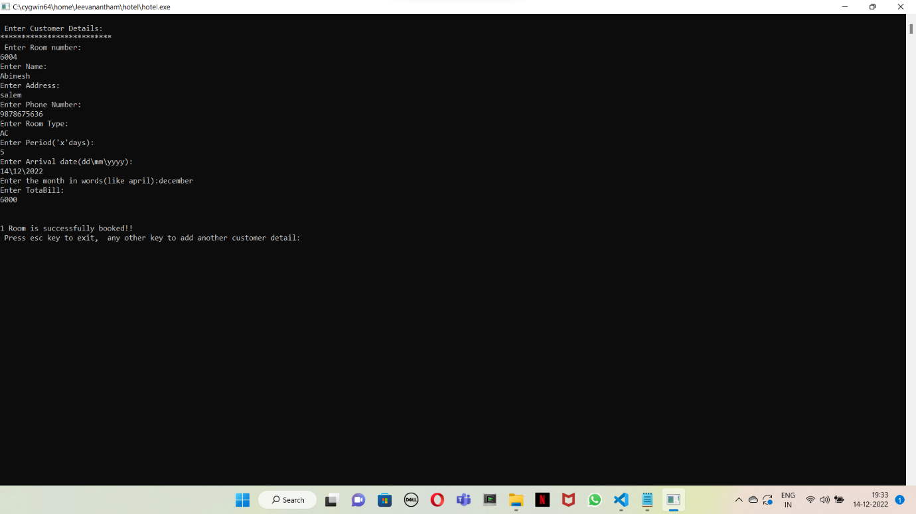

VIEWING THE RECORDS:

FIG.7:

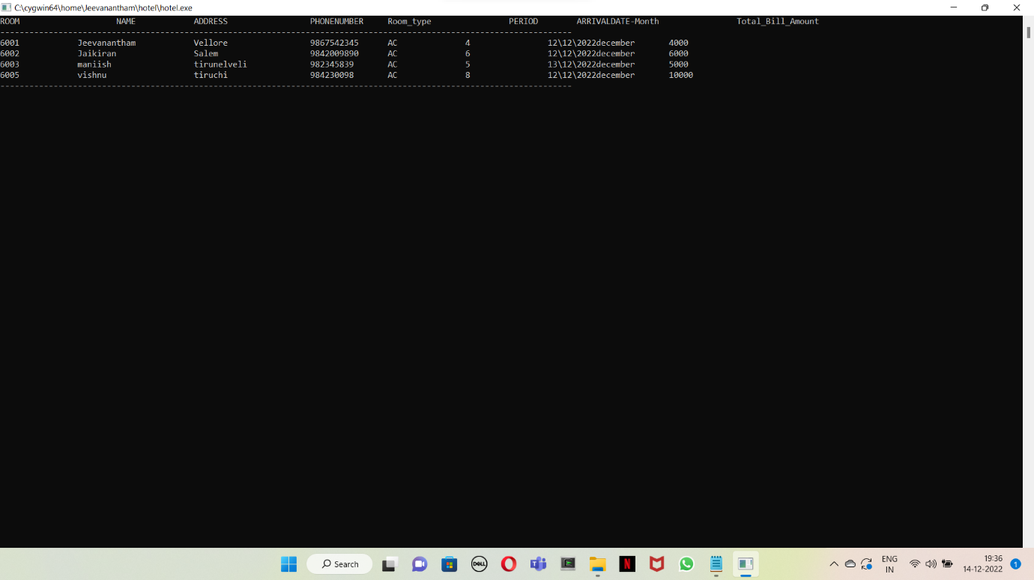

DELETING THE RECORD:

FIG.8:

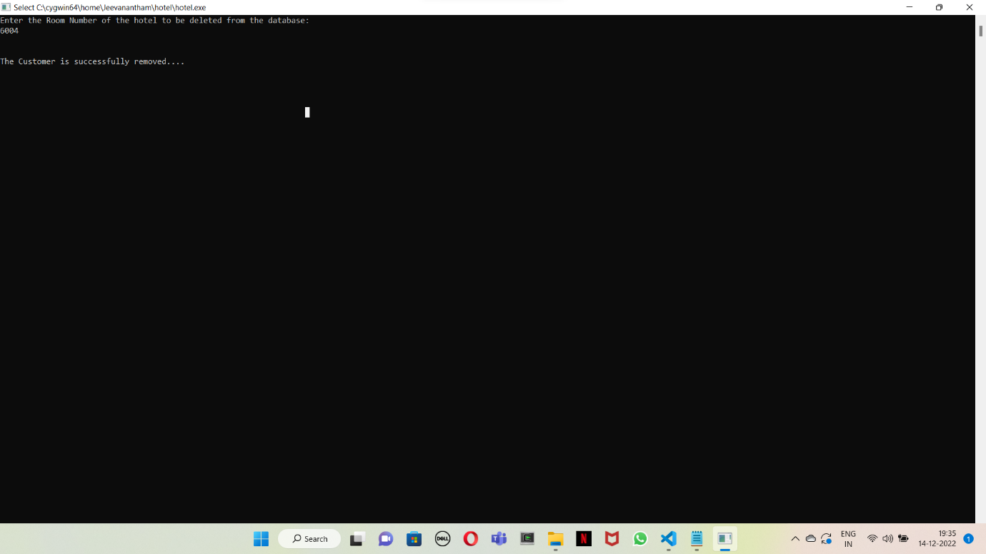

SEARCHING THE RECORD:

FIG.9:

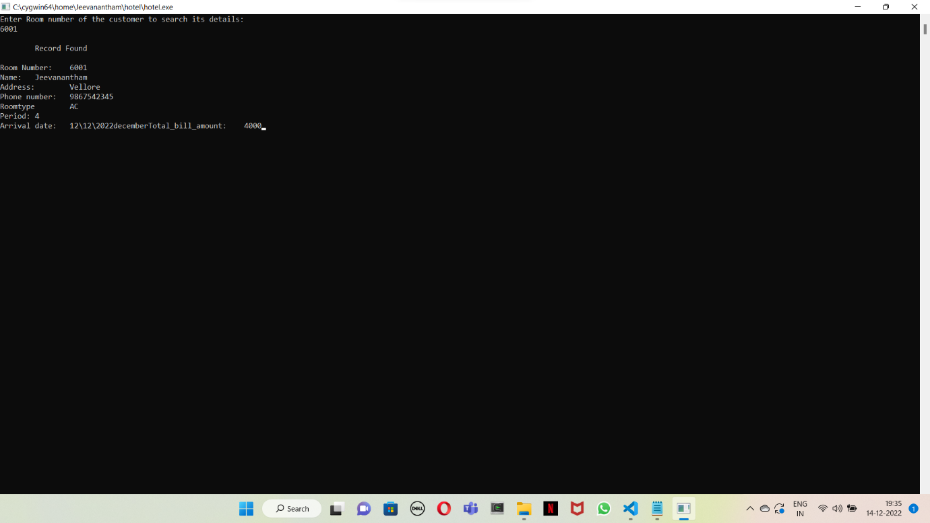

THUS THE FUNCTIONS OUTPUT HAS BEEN DISPLAYED.

THIS PROJECT HAS BEEN SUCESSFULLY IMPLEMENTED USING THE DATA STRUCTURES.